**Feedback System**

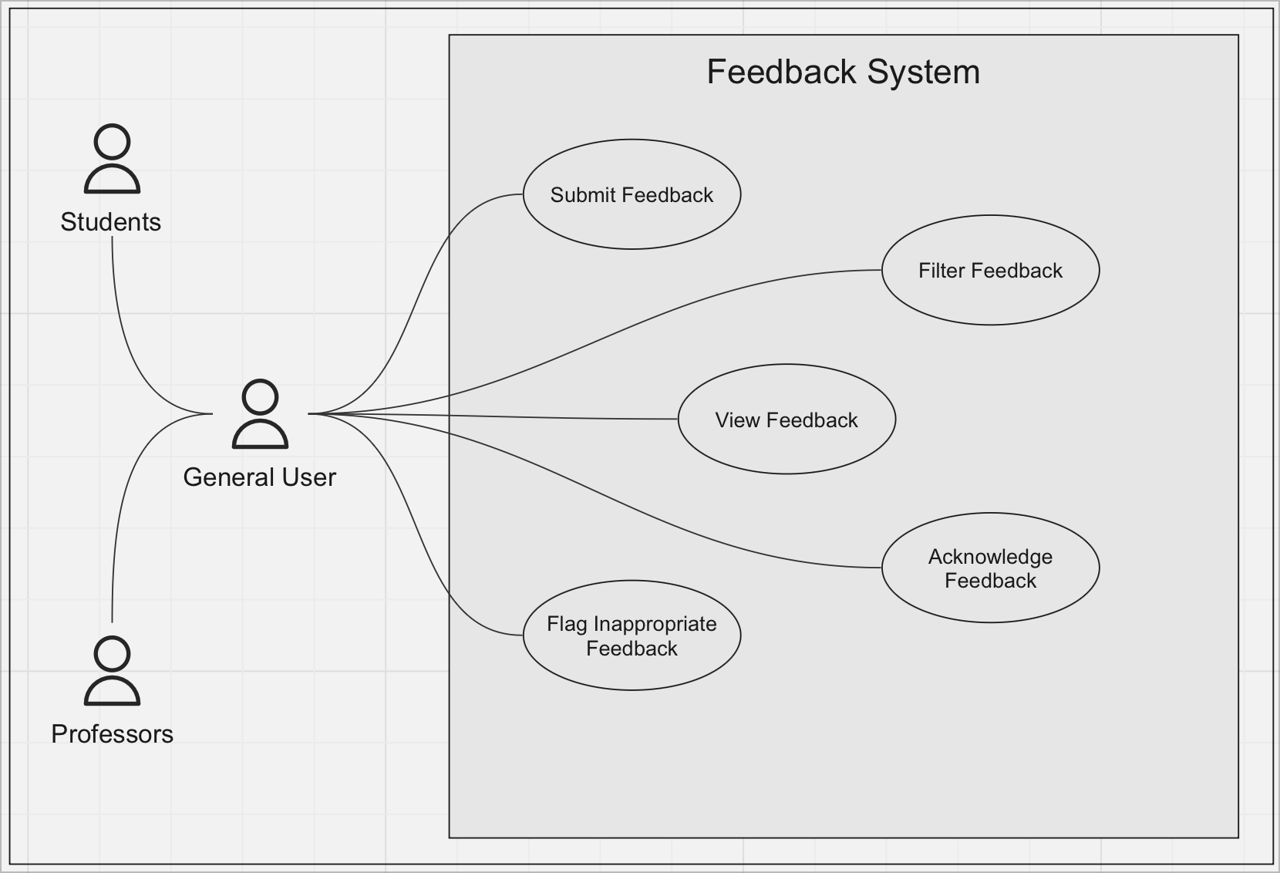

[Link to Miro Board](https://miro.com/app/board/uXjVNZ96xM0=/)

**Use Case Descriptions**

**Submit Feedback**

* **Name/Title:** Submit Feedback
* **ID:** 4138010
* **Description:** Students can post feedback about professors or courses, sharing their experiences and thoughts. While the content of the feedback may be detailed, the system ensures the anonymity of the student, promoting open communication.
* **Precondition:** Student is logged in and is on the "Submit Feedback" page.
* **Success Postcondition:** Feedback is posted on the platform, viewable to others, without revealing the identity of the student.

| Step | Actor | System | Description |
| --- | --- | --- | --- |
| 1 | Student |  | Navigates to the "Submit Feedback" page |
| 2 | Student |  | Enters feedback into the provided text area |
| 3 | Student |  | Clicks 'Submit' |
| 4 |  | System | Confirms the anonymity of the feedback |
| 5 |  | System | Posts the feedback on the platform |
| 6 |  | System | Displays a confirmation message that the feedback has been posted |

**Filter Feedback**

* **Name/Title:** Filter Feedback
* **ID:** 4138011
* **Description:** Users can filter through feedback based on specific criteria such as professor name, course code, or date. This feature enhances the user experience by allowing quick access to relevant feedback.
* **Precondition:** User is viewing a list of feedback entries.
* **Success Postcondition:** The feedback list updates to display only those entries that match the filtering criteria.

| Step | Actor | System | Description |
| --- | --- | --- | --- |
| 1 | User |  | Selects filter options like professor name, course code, or date |
| 2 | User |  | Applies the filter |
| 3 |  | System | Filters the feedback list based on the selected criteria |
| 4 |  | System | Displays the filtered list of feedback entries |

**Acknowledge Feedback**

* **Name/Title:** Acknowledge Feedback
* **ID:** 4138012
* **Description:** Professors can acknowledge feedback they've read, signaling to the student that their voice has been heard, all while retaining the student's anonymity. This feature fosters a sense of validation for the feedback given.
* **Precondition:** Professor is logged in and is viewing a specific piece of feedback.
* **Success Postcondition:** The feedback entry is marked as acknowledged, visible to other users.

| Step | Actor | System | Description |
| --- | --- | --- | --- |
| 1 | Professor |  | Views a specific piece of feedback |
| 2 | Professor |  | Clicks 'Acknowledge' on the feedback entry |
| 3 |  | System | Marks the feedback as acknowledged |
| 4 |  | System | Updates the feedback entry to reflect the acknowledgment publicly |

**Flag Inappropriate Feedback**

* **Name/Title:** Flag Inappropriate Feedback
* **ID:** 4138013
* **Description:** Users can flag feedback that they deem inappropriate or against the platform's guidelines. This ensures that the platform remains respectful and adheres to community standards.
* **Precondition:** User is viewing a feedback entry and believes it to be inappropriate.
* **Success Postcondition:** The feedback is flagged for review by the platform administrators.

| Step | Actor | System | Description |
| --- | --- | --- | --- |
| 1 | User |  | Identifies a feedback entry as inappropriate |
| 2 | User |  | Clicks 'Flag as Inappropriate' next to the feedback entry |
| 3 |  | System | Confirms the flag action and asks for a reason (optional step) |
| 4 | User |  | Submits the reason for flagging (if required) |
| 5 |  | System | Flags the feedback for review and notifies platform administrators |

**View Feedback**

* **Name/Title:** View Feedback
* **ID:** 4138014
* **Description:** Users can browse and read feedback entries shared by students. The platform provides an interface where feedback can be easily accessed and read, with the assurance that all feedback retains the anonymity of the original poster.
* **Precondition:** User is on the platform looking to gather insights from feedback.
* **Success Postcondition:** The user successfully views various feedback entries and gains insights from them.

| Step | Actor | System | Description |
| --- | --- | --- | --- |
| 1 | User |  | Browses to the feedback section of the platform |
| 2 |  | System | Displays a list of feedback entries |
| 3 | User |  | Selects a feedback entry to read |
| 4 |  | System | Opens the full feedback entry for the user to read |
| 5 | User |  | Navigates back to the list or proceeds to another feedback entry |